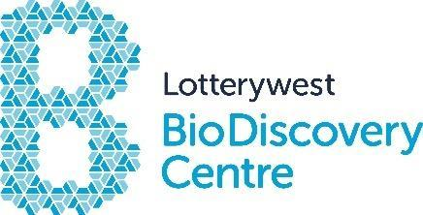
Lotterywest BioDiscovery Centre
PERKINS PROFS ACADEMY - OPEN CLASS
Application Form
Thank you for your interest in this program. Can you please complete the form below and return by email to education@perkins.org.au.
You will be notified if your application was successful within seven (7) business days. Applications are processed on a first come first served basis.
Student Details
Name
Email
Phone (if applicable)
School
Year
Program details
Program Dates  Please tick your preferred date | ☐ Term 2 Tuesdays 2024 (first day: 16 April - last day: 18 June)  ☐ Term 4 Tuesdays 2023 (first day: 8 October - last day: 10 December)
Medical conditions/food allergies | ☐No  ☐Yes, please state  Click here to enter text.
Parent details
Name
Address
Suburb |  | Postcode
Phone
Email
Signature
Mailing list
If you would like to join the Perkins mailing list to receive information about the Institute and upcoming events and seminars tick the box below:
I would like the Perkins to email me information ☐

Photographs
The Harry Perkins Institute of Medical Research uses photographs and video footage to promote its research projects.
Images may be used:
- by the Institute for publications such as Annual Reports, newsletters, brochures, websites, videos and flyers.
- by the media for the purposes of promoting the Institute and its research.
I give permission for my child to be photographed by the Institute for the promotion of the Harry Perkins Institute of Medical Research.
Yes ☐ No ☐
How did you hear about this Program?

Program Details
This program will run for 10 weeks and is offered in Terms 2 and 4. Students will attend the Harry Perkins Institute of Medical Research once a week on a Tuesday for a two-hour session after school from 4.30pm – 6.30pm.
This course will allow students a unique opportunity to work alongside real medical research scientists using research grade equipment. The course will feature laboratory based investigations, techniques and skills plus essential knowledge of how cancer as a disease is researched at the Harry Perkins Institute of Medical Research.
Aspects of the program change but include training for PC2 Laboratory operations, techniques of aseptic techniques and cell staining, use of fluorescent microscopy, genetic manipulation techniques and protein analysis. You will be notified of the details of your program when you apply.
Dress Requirements
Completely covered/enclosed footwear (e.g. Joggers), NO ballet flats! Long hair and fringes tied back.
Payment
The cost of the program is $370 per student to be paid no later than two (2) weeks prior to the start of the course. Your position will be secured once payment is received. Payment can be made by electronic transfer. Details will be sent to you after your application has been processed.
Cancellation Policy
A refund of registration fee will only be made if the Centre is notified at least one (1) week prior to the commencement of the program
☐ I acknowledge that I have read and agree to the terms stated above
Date:
Signature:

