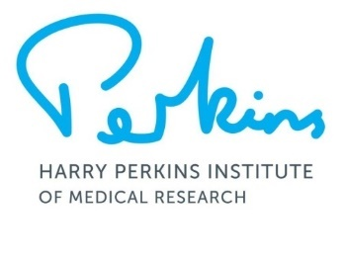
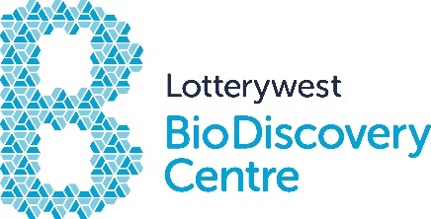
Lotterywest BioDiscovery Centre
Immersion Program Application Form 2024
Thank you for your interest in this program. Please complete the form below and return by email to education@perkins.org.au.
You will be notified if your application is successful at least 4 weeks prior to the Program start date. Five (5) applicants will be selected to attend each Program after reviewing all applications. Unsuccessful applicants will automatically go onto the applicant list for the next program.
Student Details
Name
Email
Phone
School
Year
Program details
Program Date (tick all you are available for) | ☐ 22-24 Jan 2024  ☐ 9-11 April 2024  ☐ 9-11 July 2024  ☐ 1-3 Sept 2024
Medical conditions/food allergies | ☐ None  ☐ Yes, please give details:  Click here to enter text.
In 200 words or less, explain why you would like to participate in this program.
Click here to enter text.

As part of this application, you are required to ask your current science teacher if they will sign this form in recognition of your suitability for the program.
Teacher’s Name
Email (optional)
Signature
Date
Program Details
The Immersion Program runs from 9am to 3pm Tuesday to Thursday in the last week of every school holidays. Aspects of the program change according to the availability of researchers and the work being conducted in associated labs. You will be notified of the details of your program when your application is confirmed.
Lunch is not provided, however, there are cafés located on the ground floor and in the adjacent hospital that will be accessible.
Dress Requirements
Completely covered/enclosed footwear (e.g. Joggers) NO ballet flats! Long hair and fringes tied back. Lab coats and other PPE will be provided.

Parent details
Name
Address

Suburb |  |  | Postcode
Phone
Email
Signature
Photographs
The Harry Perkins Institute of Medical Research uses photographs and video footage to promote its research projects and other activities.
Images may be used:
- by the Institute for publications such as Annual Reports, newsletters, brochures, websites, social media, videos and flyers.
- by the media for the purposes of promoting the Institute and its activities.
I give permission for my child to be photographed by the Institute for the promotion of the Harry Perkins Institute of Medical Research.
Yes ☐ No ☐
Mailing list
If you would like to join the Perkins mailing list to receive information about the Institute and upcoming events and seminars tick the box below:
I would like the Perkins to email me information ☐
How did you hear about this Program?
Payment
The cost of the program is $375 to be paid no later than 2 weeks prior to the start of the course. Your position will be secured once payment is received. Payment can be made by electronic transfer.
Payment details will be sent to your nominated email address if your application is successful.
Cancellation Policy
A refund of registration fee will only be made if the centre is notified by one week prior to the commencement of the program.
☐ I acknowledge that I have read and agree to the terms stated above
Date:
Signature:
Community Engagement and Education Team
Lotterywest BioDiscovery Centre
Harry Perkins Institute of Medical Research
6 Verdun Street
Nedlands WA 6009
T: (08) 6151 0811

