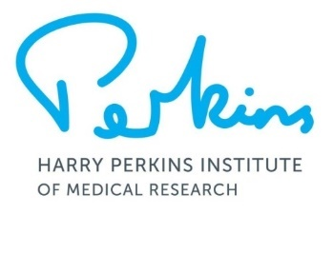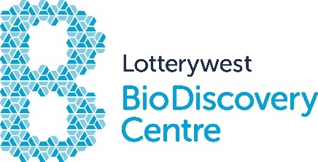**Lotterywest BioDiscovery Centre**

**Immersion Program Application Form**

Thank you for your interest in this program. Can you please complete the form below and return by email to [**education@perkins.org.au**](mailto:education@perkins.org.au).

You will be notified if your application was successful at least 4 weeks prior to the Program start date. Five applicants will be selected to attend each Program after reviewing all applications. Unsuccessful applicants will automatically go onto the applicant list for the next program.

|  |  |
| --- | --- |
| **Student Details** | |
| Name |  |
| Email |  |
| Phone |  |
| School |  |
| Year |  |
| **Program details** | |
| Program Date (tick all you are available for) | 3rd Oct ­– 5th Oct **2023**  22rd Jan – 24th Jan **2024** |
| Medical conditions/food allergies | No  Yes, please state  Click here to enter text. |
| In the space below, in less than 200 words, explain why you would like to participate in this program.  Click here to enter text. | |
| As part of this application, you are required to ask your current science teacher if they will sign this form in recognition of your suitability for the program. | |
| Teacher’s Name |  |
| Email (optional) |  |
| Signature |  |
| Date |  |

**Program Details**

The immersion program is run from 9:00am to 3:00pm Tuesday to Thursday in the last week of every school holidays. Aspects of the program change according to the availability of researchers and the work being conducted in associated labs. You will be notified of the details of your program when you apply.

Lunch is not provided, however, there are cafes located on ground floor and in adjacent hospital that will be accessible.

**Dress Requirements**

Completely covered/enclosed footwear (e.g. Joggers) NO ballet flats! Long hair and fringes tied back.

|  |  |  |  |  |
| --- | --- | --- | --- | --- |
| **Parent details** | | | | |
| Name |  | | | |
| Address |  | | | |
| Suburb |  | | Postcode |  |
| Phone |  | | | |
| Email |  | | | |
| Signature |  | | | |
| **Photographs** | | | | |
| The Harry Perkins Institute of Medical Research uses photographs and video footage to promote its research projects.  Images may be used:   * by the Institute for publications such as Annual Reports, newsletters, brochures, websites, videos and flyers. * by the media for the purposes of promoting the Institute and its research. | | | | |
| I give permission for my child to be photographed by the Institute for the promotion of the Harry Perkins Institute of Medical Research.  Yes ☐ No ☐ | | | | |
| **Mailing list** | | | | |
| If you would like to join the Perkins mailing list to receive information about the Institute and upcoming events and seminars tick the box below: | | | | |
| I would like the Perkins to email me information | | | | |
| **How did you hear about this Program?** | |  | | |

**Payment**

The cost of the program is $350 to be paid no later than 2 weeks prior to the start of the course. Your position will be secured once payment is received. Payment can be made by electronic transfer.

Payment details will be sent to your nominated email address if the application is successful.

**Cancellation Policy**

A refund of registration fee will only be made if the centre is notified byone week prior to the commencement of the program.

**I acknowledge that I have read and agree to the terms stated above**

**Date**:

**Signature:**

Community Engagement and Education Team

Lotterywest BioDiscovery Centre

Harry Perkins Institute of Medical Research  
6 Verdun Street

**Nedlands**  WA   6009

T: 6151 0811